**Future Sales Prediction Using Machine Learning**

**Team Members**

1. A.S.Jensing Samuel
2. S.V.Mageshwar
3. T.Dilli Ganesh
4. R.Devanesan
5. A.Kalaivendhan

**Phase- 3 Project Document**

**Project Title:** Future Sales Prediction

**Phase-3 :** Project Development part 1

**Topic:** Building our project by loading and preprocessing the dataset. Begin building the future sales prediction model by loading and preprocessing the dataset. Load the historical sales dataset and preprocess the data for analysis.

**Future Sales Prediction**

**Introduction:**

In today's rapidly changing business landscape, organizations across various industries are seeking ways to optimize their operations, reduce risks, and enhance decision-making. One key aspect of achieving these goals is the ability to accurately predict future sales. Sales prediction is crucial for inventory management, financial planning, and overall business strategy. Machine learning, with its predictive capabilities, offers a powerful tool for solving this challenge.

* This project aims to develop a robust future sales prediction model using machine learning techniques. By analyzing historical sales data, we will leverage the power of data-driven insights to forecast future sales trends.
* This future sales prediction project using machine learning holds the promise of transforming how businesses plan and execute their sales strategies. By harnessing the power of historical sales data and advanced machine learning techniques, we aim to provide organizations with more accurate, timely, and actionable sales forecasts. These forecasts can drive growth, optimize operations, and empower businesses to make data-informed decisions in an ever-evolving market. This project represents a step forward in the journey towards data-driven excellence and strategic success.

**Data Source**

A good data source for house price prediction using machine learning should be Accurate, Complete, Covering the geographic area of interest, Accessible.

**Dataset Link:**<https://www.kaggle.com/datasets/chakradharmattapalli/future-sales-prediction>

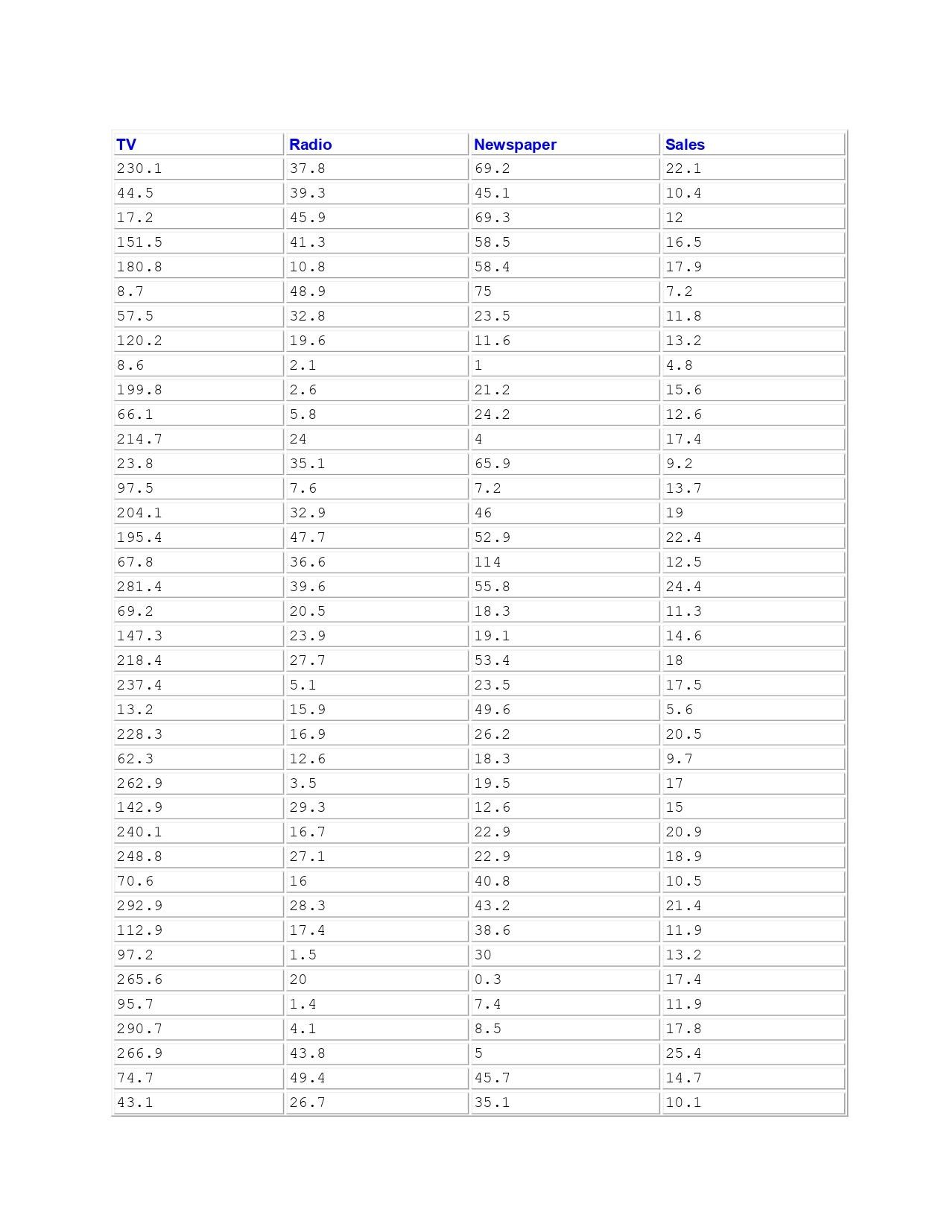

201 Rows x 4 Columns

**Necessary Step to Follow:**

1. **Import Libraries:**

Start by Importing the necessary libraries.

**Program:**

import pandas as pd

import numpy as np

import matplotlib.pyplot as plt

import seaborn as sns

from sklearn.model_selection import train_test_split

from sklearn.preprocessing import StandardScaler

**2.Load the Dataset:**

Load your dataset into a Pandas DataFrame. You can typically find

Future Sales Prediction datasets in CSV format, but you can adapt this

code to otherformats as needed.

**Program:**

data = pd.read_csv('sales_data.csv')

**3.Exploratory Data Analysis(EDA):**

Perform EDA to understand your data better. This includes

checking for missing values, exploring the data's statistics, and

visualizing it to identify patterns.

**Program:**

print(data.describe())

print(data.info())

print(data.isnull().sum())

#Visualize data for insights

sns.pairplot(data)

plt.show()

**4.Feature Engineering:**

Depending on your dataset, you may need to create new features or

transform existing ones. This can involve one-hot encoding categorical

variables, handling date/time data, or scaling numerical features.

**Program:**

# In this example, let's create lag features for time series data

data['lag_1'] = data['sales'].shift(1) # Create a lag feature with a 1-day shift

data['lag_7'] = data['sales'].shift(7) # Create a lag feature with a 7-day shift

**5.Spilit the Data:**

Split your dataset into training and testing sets. This helps you

evaluate your model's performance later.

**Program:**

X = data.drop('sales', axis=1) # Features

y = data['sales'] # Target variable

# Split the data into training and testing sets (e.g., 80% train, 20% test)

X_train, X_test, y_train, y_test = train_test_split(X, y, test_size=0.2,

random_state=42)

**6.Feature Scaling:**

Apply feature scaling to normalize your data, ensuring that all

features have similar scales. Standardization (scaling to mean=0 and

std=1) is a commo n choice.

**Program:**

scaler = StandardScaler()

X_train_scaled = scaler.fit_transform(X_train)

X_test_scaled = scaler.transform(X_test)

**Importance of loading and processing dataset:**

Loading and preprocessing the dataset is an important first step in

building any machine learning model. However, it is especially

important for house price prediction models, as house price datasets are

often complex and noisy.

By loading and preprocessing the dataset, we can ensure that the

machine learning algorithm is able to learn from the data effectively and

accurately.

**Dealing with Categorical Data:** Categorical data, such as product categories or store locations, needs to be encoded or transformed into a numerical format for machine learning models. Deciding on the appropriate encoding method can be a challenge.

**Time Series Data:** Sales prediction often involves time series data. Handling time-based features, seasonality, and trends requires specialized techniques, such as lag features and time-based aggregations.

**Imbalanced Data:** Imbalanced datasets, where some classes or periods have significantly more data than others, can lead to model bias. Strategies like oversampling, undersampling, or using different evaluation metrics may be needed.

**Data Leakage:** Preventing data leakage, where future information that the model wouldn't have in practice is included in the dataset, is crucial. This can distort model performance and lead to overfitting.

**Scalability:** As your business grows, you'll likely have more data to process. Ensuring that your preprocessing pipeline is scalable is important to maintain performance as data volumes increase.

**Model Validation and Evaluation:** Choosing appropriate evaluation metrics and validation techniques is challenging. Depending on the specific sales prediction problem, you may need to consider metrics like Mean Absolute Error (MAE), Mean Squared Error (MSE), or time series-specific metrics like Mean Absolute Scaled Error (MASE).

**Ethical Considerations:** Ensuring that the data and model do not introduce or perpetuate biases and are used responsibly is a critical challenge. Careful data selection and bias mitigation strategies are essential.

**Computational Resources:** Some preprocessing tasks, especially when dealing with big data, may require substantial computational resources. You may need access to powerful hardware or cloud-based solutions.

**How to overcome the challenges of loading and preprocessing a house price dataset**

Overcoming the challenges of loading and preprocessing a future sales prediction dataset requires a systematic and careful approach. Here are some strategies to address these challenges.

**Data Quality and Consistency:**

* Data Cleaning: Develop scripts or procedures to handle missing values, outliers, and inconsistencies. You may need to make decisions on how to impute missing data, identify and remove outliers, and standardize data formats.
* Data Validation: Regularly validate the data against expected ranges and constraints. Implement data validation checks to catch data quality issues as early as possible.

**Data Volume:**

* Data Sampling: If dealing with large datasets, consider working with a random sample to develop and test your preprocessing pipeline before applying it to the entire dataset.
* Distributed Processing: Utilize distributed computing frameworks like Apache Spark to handle large datasets efficiently.

**Data Integration:**

* Data Integration Tools: Use ETL (Extract, Transform, Load) tools or data integration platforms to merge data from different sources into a single dataset.
* Data Schema Mapping: Ensure that data from different sources are mapped correctly to a common schema.

**Feature Engineering:**

* Domain Expertise: Collaborate with subject-matter experts to identify relevant features and understand the nuances of the data.
* Automated Feature Selection: Explore automated feature selection techniques to identify the most informative features.

**Dealing with Categorical Data:**

* One-Hot Encoding: Convert categorical data into binary vectors using one-hot encoding or techniques like Label Encoding.
* Feature Embedding: Consider techniques like word embeddings for high cardinality categorical variables.

**Time Series Data:**

* Lag Features: Create lag features to capture time dependencies.
* Seasonal Decomposition: Use seasonal decomposition techniques to identify and remove seasonality and trends from time series data.

**Imbalanced Data:**

* Resampling: Employ techniques such as oversampling (for minority classes) and undersampling (for majority classes) to balance the dataset.
* Different Models: Consider using models that handle imbalanced data well, such as ensemble methods or specialized algorithms.

**Loading the dataset**

Loading the dataset using machine learning is the process of bringing

the data into the machine learning environment so that it can be used

to train and evaluate a model.

The specific steps involved in loading the dataset will vary depending

on the machine learning library or framework that is being used.

However, there are some general steps that are common to most

machine learning frameworks.

1. **Identify the dataset:**

The first step is to identify the dataset that you want to load. This

dataset may be stored in a local file, in a database, or in a cloud storage

service.

1. **Load the dataset:**

Once you have identified the dataset, you need to load it into the

machine learning environment. This may involve using a built-in

function in the machine learning library, or it may involve writing your

own code.

1. **Preprocess the dataset:**

Once the dataset is loaded into the machine learning environment,

you may need to preprocess it before you can start training and

evaluating your model. This may involve cleaning the data, transforming

the data into a suitable format, and splitting the data into training and

test sets.

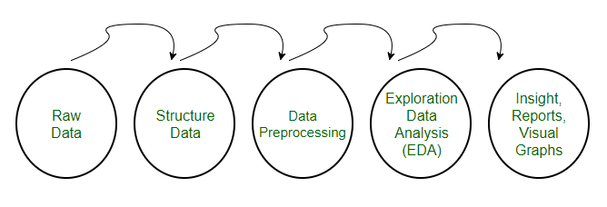

*Here, how to load a dataset using machine learning in Python*